**Bio-Lab**

**Concept Name**

* Bio-Lab

**Genre**

* Puzzle

**Core Mechanic**

* Solve puzzle with physic mechanic

**Progressive Mechanics**

* Solve Puzzle

**Goal Mechanic**

* Solve all puzzle

**Play Mechanics**

* Arrow key to control the character
* Space to jump
* E to grab or interact

**User Experience**

* Beginning of the game player will get the tutorial by play in first state

After player know how to play in each level will increase difficulty and player will fight with boss at the end of the game

**Theme**

* Present world
* Science, bio-lab

**Story**

* Subject No.17 is the new subject of neo-human project of Renewal Inc. or Re Corporation to create the human with perfect performance but No.17 realize he was created and he’s need to escape and find the new life as regular human.

**Ref.**

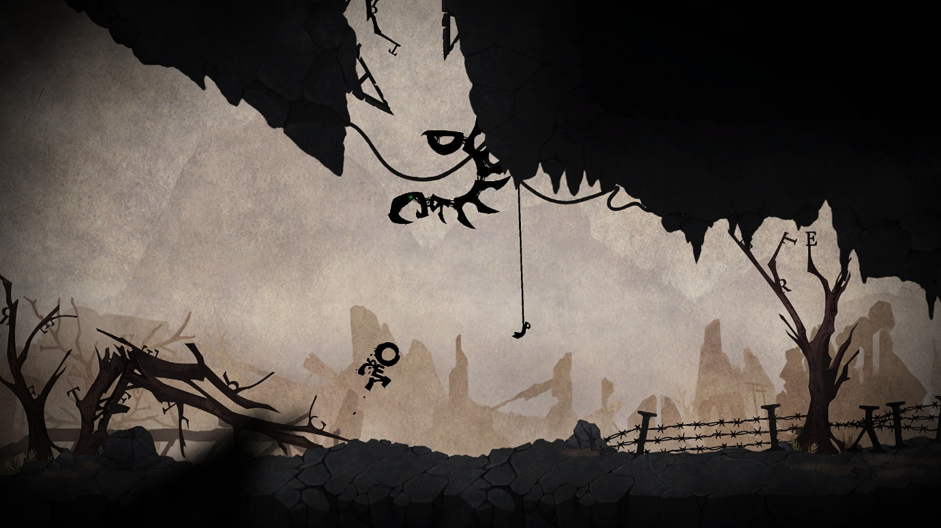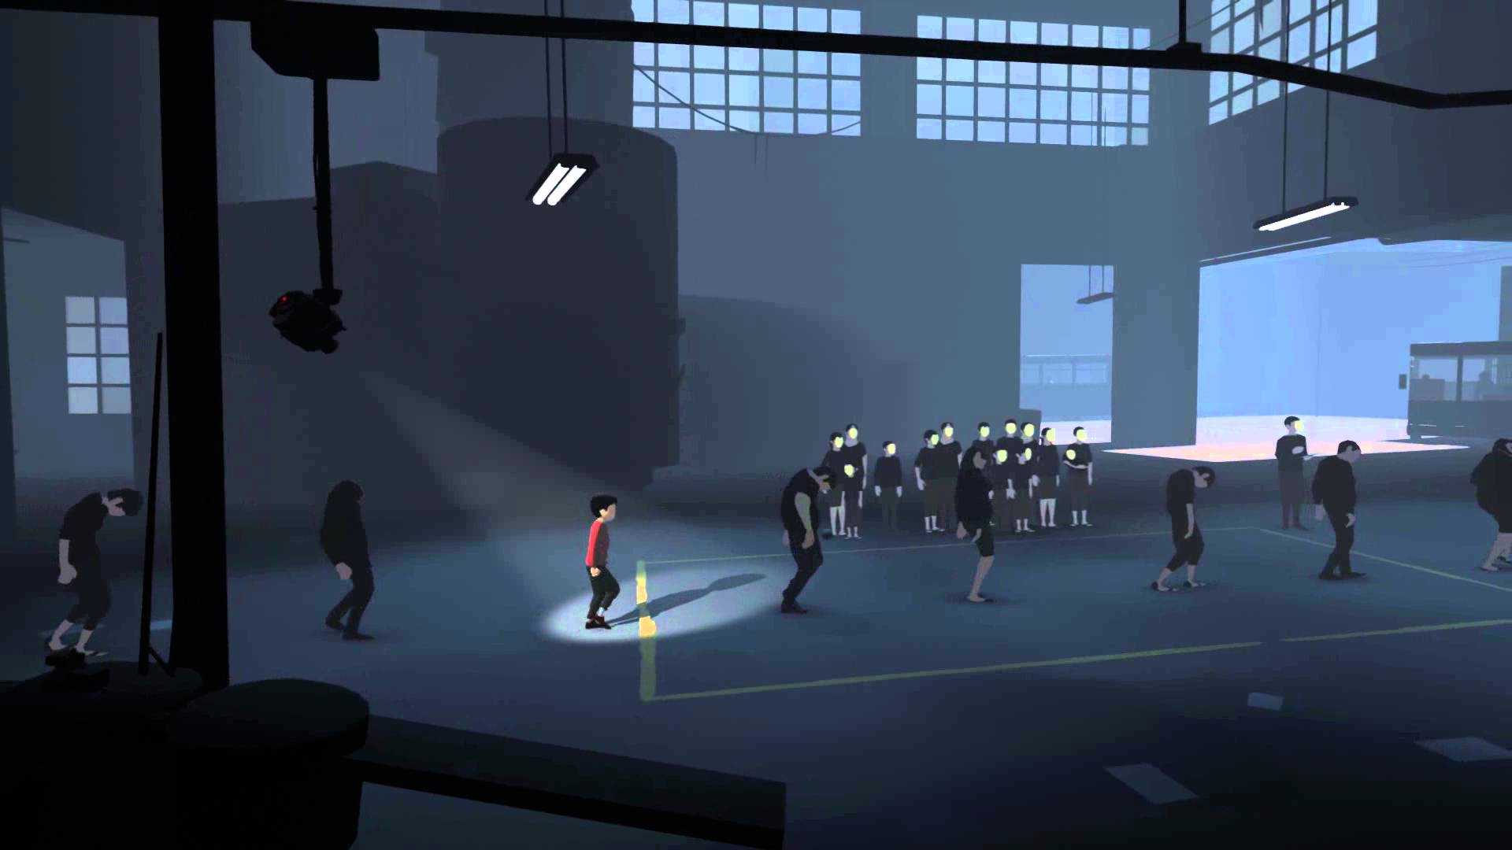 *INSIDE*

*Typoman*